

System Design Document

Version 2.1
March 6, 2006

CPSC 319
Team 7

UBC Botanical Garden and Centre for Plan Research

Dr. Andrew Riseman




Revisions

Version | Primary Author(s) | Description of Version | Date Completed
1.0 | Jack Liu | This is the initial draft of the System Design Document. | Feb 16, 2006
1.1 | Jack Liu, Susannah Poon, Jason Hui | Sections added and edited for initial evaluation. | Feb 20, 2006
2.0 | Jack Liu, Jason Hui, Charles Bihis | Document changed to reflect changes made in architecture. | Feb 28, 2006
2.1 | Gabriel Lee, Susannah Poon, Jason Hui, Jimmy Wong, Jack Liu | Revised sections and incorporated the feedback from the first draft | Mar 6, 2006

Table of Contents
Revisions i
Table of Contents ii
1. Introduction - 1 -
1.1 System Overview - 1 -
1.2 Supporting Materials - 1 -
1.3 Definitions and Acronyms - 2 -
2. Design Considerations - 4 -
2.1 Assumptions - 4 -
2.2 Constraints - 4 -
2.3 System Environment - 5 -
3. Architecture - 6 -
4. High Level Design - 9 -
4.1 Conceptual View - 9 -
4.1.1 Page Subsystem - 9 -
4.1.2 Simulation Subsystem - 9 -
4.1.3 Database Subsystem - 9 -
4.1.4 Log Subsystem - 10 -
4.1.5 Handler Subsystem - 10 -
4.2 User View - 10 -
５．Low Level Design - 11 -
5.1 Modules - 11 -
5.1.1 Page Module - 11 -
5.1.2 Simulation Module - 12 -
5.1.3 DatabaseManager Module - 14 -
5.1.4 Logger Module - 14 -
5.1.5 Handler - 14 -
5.2 Sequence Diagrams - 15 -
5.2.1 Common Login Sequence Diagram - 16 -
5.2.2 Common Logout Sequence Diagram - 18 -
5.2.3 Plant Cookie Sequence Diagram - 19 -
5.2.4 Verify Cross Sequence Diagram - 20 -
5.2.5 Solve Problem Sequence Diagram - 21 -
5.2.6 [Action] [Object] Sequence Diagram - 23 -
6. User Interface Design - 25 -
6.1 Application Control - 25 -
6.1.1 Common Look and Feel - 25 -
6.1.2 Common Behaviour - 25 -
6.2 Screens - 26 -
6.2.1 Screen Venn Diagram - 26 -
6.2.1.1 Common Pages for All Users - 27 -
6.2.1.2 Pages for Administrator, Professor, TA - 27 -
6.2.1.3 Pages for Administrator, Professor - 27 -
6.2.1.4. Pages for Student - 27 -
6.2.2 Login - 28 -
6.2.3 Logout - 29 -
6.2.4 Change Password - 30 -
6.2.5 Lists - 30 -
6.2.6 Object Details - 36 -
6.2.7 Problem Details - 37 -
6.2.8 Problem Solution Details - 37 -
6.2.9 Submit Problem - 40 -

1. Introduction

1.1 System Overview
XGene 360 is a web-based application that will serve as a teaching aid for quantitative genetics. The students will be able to solve the problem parameters defined by the professor by working with plant breeding simulations within the application. Moreover, XGene 360 will simulate plant breeding between diploid plants of the same species under similar environment conditions, and employ the basic concepts and principles of plant breeding and quantitative genetics.

A user of the application will be able to login to the application, as well as change their passwords, and view a list of selected problems. An administrator will have full access to all professor functions and all accounts. Administratively, the professor will be able to create/remove/modify user accounts and have the option to remove data for a past course. In terms of specifying a problem for students to solve, a professor will be able to generate a unique problem for each student user by specifying the mean, standard deviation, heritability factor and the number of genes for two independent (non-linked) traits in a parent generation. The professor will also be able to assign problems to courses, students or TAs, view a student’s progress and provide feedback to a student’s solution. Teaching assistants (TAs) will also be able to view the progress of any student from a course assigned to them and leave feedback for student solutions. The students will be able to view a list of problems, and from there select any number of offspring for inter-crossing to generate the next generation. Through the manipulation and analysis of progeny, students will be able to determine the problem parameters based on the principles of quantitative plant breeding genetics without any further assistance from the application.

The logic of the application will be written in PHP, while the user interface of the application will be written in HTML, complemented with CSS and JavaScript. Database access will be managed by the use of SQL queries. The system will be composed of five subsystems: Page, Simulation, Database, Logger, and Handler. Each subsystem will specialize in different aspects of the application but will be coupled in various relationships since they rely on each other’s functionality. Each subsystem will be described in detail in section 4.1, Conceptual View.

The application will run on an Apache web server with MySQL as the DBMS. The clients will be required to use web browsers such as Internet Explorer, Firefox, or Safari. For more information about the browser requirements, please refer to Section 2.2 Constraints.

1.2 Supporting Materials
System Design Specification Template, Kurt Eiselt, 2006
System Requirement Specification, CS319 Team 7, 2006
Project Plan, CS319 Team 7, 2006

1.3 Definitions and Acronyms
ACID | A database theory concept that sets forward four goals for a database management system: atomicity, consistency, isolation and durability.
administrator | A user of the system which has all the functionalities of a professor but also has access to all accounts.
CGI | The common gateway interface (CGI) specifies a standard which enables a user’s browser to send requests to the web server.
client | Dr. Andrew Riseman, Assistant Professor, UBC Botanical Garden and Centre for Plant Research.
course | Created by the professor, contains a group of students.
cross | The deliberate mating of two parental types of organisms in genetic analysis.
CSS | A Cascading Style Sheet (CSS) provides formatting and styles for HTML pages
DBMS | Database management system
genes | The effective factor that is affecting a trait.
generation | An iteration of the genetic algorithm. Each generation contains the plants that the student selected, and the offspring that the software generated.
HTML | Hypertext Markup language is used for creating web pages which be viewed by users using a browser.
HTTP | Hypertext transfer protocol is the way in which browsers talk to web servers when they are making requests for web pages or file objects.
interpreted language | An interpreted language, like PHP, describes an implementation issue of a language where the program can be executed in its source form with an interpreter.
PHP | PHP is a scripted programming language commonly used for web applications to generate dynamic HTML pages.
problem | Created by the professor, it generates the progeny base on its parameters specified by the professor.
professor | A user of system who is able to create/modify/remove students, teaching assistants, courses and problems for the course he/she is managing.
progeny | The resulting offspring from a cross.
quantitative genetics | The study of genetic basis of continuous variation in phenotype.

student | A user of the system who works on his/her assigned problems by stimulating plant breeding.
subsystem | A unit or device that is part of a larger system (i.e. parts of the application).
teaching assistant (TA) | A user of the system who can view a student’s progress.
trait | A genetic feature that maybe passed from one generation to the next.
URL | Uniform Resource Locator. An address that a user would type into their browser to reach a web page.
user | Refers to a general user of the system.
YellowLeaf | A project previously developed by another team. An interactive web based plant breeding simulation software project with qualitative genetics written in PHP with MySQL DBMS.

2. Design Considerations

2.1 Assumptions
It will be assumed that all users of the system know the Uniform Resource Locator (URL) for which will give the user access to the application. Users will have the ability to use computers with an Internet connection and a browser. It will also be assumed that a user will be able to operate a web browser and navigate the Internet at an adequate level.

There will be an assumption that the administrator and professors have basic knowledge of how to use the computer, particularly the web browser. It will also be assumed that the administrator and professors have decent knowledge of plant genetics, particularly quantitative plant genetics, in order to understand the application’s nomenclature and interface.

It will be assumed that the students and TAs have basic knowledge of how to use the computer, the web browser and the Internet. The students will be required to have enough knowledge of plant genetics in order to understand and work on the problem assigned to them. The TAs will be required to have enough knowledge of plant genetics in order to understand and evaluate problems assigned to them.

The client will provide the developers with a server for application testing, with the server constraints as stated in the section below.

2.2 Constraints
By restrictions specified from the client, the software will be written in an interpreted language. The software will be installable via a simple drag-and-drop function that will require minimal technical knowledge. The software will not modify or move any other software on the server. To meet these requirements, the software will be developed in the interpreted language, PHP, and will be platform independent. The server must support the following:

- Apache 1.3.33
- MySQL 3.23
- PHP 4.3.10

Final application testing will be done on a Macintosh G4 running on Mac OS X 10.2.8.

The system will be able to support up to 100 concurrent users simultaneously accessing the system without any noticeable slowdowns. It will be assumed that this is below the threshold of hardware resources and server configuration, and that no other software on the server will be taking up significant amounts of resources.

All creations, modifications, deletions, and incorrect logins will be logged in the system log accompanied by a timestamp. The logs will only be accessible from outside the application and further details will be beyond the scope of this document. If time permits, a view log function will be presented to the configuration manager, and will be implemented for the Administrator and Professor as a means of accessing the log through the application. Examples of logged actions include the creation of a TA or the modification of a problem.

Failures in the application will not cause any errors in the physical server or other applications running on the server. The application will be able to function reliably for a minimum of two days, which will be the time required for students to finish a particular problem.

The administrator, professors, TAs, and students will not be able to access the backend database directly for security issues. All transactions will be done through PHP functions. Students will not have access to the solutions to a problem that is currently being solved. Also, students will not have access to the log files.

The software will not require any maintenance. The professor will be given the option to remove data for past courses. For as long as the web server is up and running, the application will be running as well. Backup of the database will be handled by the server’s administrator and will be beyond the functionality of the application and the control of the developers.

2.3 System Environment
The software will run on an Apache 1.3.33 web server with PHP 4.3.10 and MySQL 3.23 installed. This application will be accessible online through a URL address.

The administrator, professors, TAs, and students will all use a web browser to access the application at a specified URL address. They will be able to view the application on a web browser that is fully compliant with HTML 4.0, CSS 1.0, and JavaScript. Some examples of web browsers that will be compliant with the application are Microsoft Internet Explorer 6, Mozilla FireFox 1.0, and Apple Safari 1.2. The usage of this application on non-compliant browsers will not be warned or restricted, but the application may not perform visually and functionally as intended by the developers. If development time permits, the system will check that JavaScript and session cookies are enabled on the user’s browser.

3. Architecture

3.1 Overview

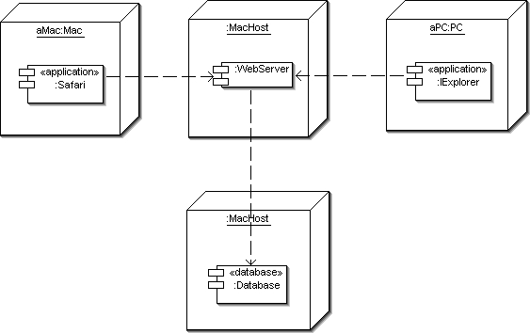

XGene 360 will be based on the 3-tier architecture model. This architecture will consist of three main components:

- Client-tier, which will be the web browser on the client machine. In the above diagram, the Client-tier is represented by the applications, IExplorer and Safari.
- Application-tier, which will be the PHP application logic layer. In the above diagram, the Application-tier is represented by WebServer.
- Data-tier, which will be the relational database used to store persistent data. In the above diagram, the Data-tier is represented by Database.

Boundaries between tiers will be logical. One or more tiers may, and will, reside on the same server system. The MySQL DBMS responsible for the Data-tier will be on the same system as the Application-tier, but will not be limited to this constraint. Additionally, a Bridge pattern will be used to access the Data-tier from the Application-tier.

3.1.1 Client-tier
The Client-tier will consist of the Internet-connected web browser used to access XGene 360. The client system environment is outlined in Section 2.2. The Client-tier will be responsible for data presentation and creating event-driven flow control to the Application-tier. JavaScript will be used to allow for user interaction with the data presented on the browser’s screen.

3.1.2 Application-tier
All PHP files will be a part of the Application-tier and will be available to the Client-tier upon user login and authentication. All application logic and processing will be stored and executed as part of the Application-tier. Individual pages will include a common header, navigation, and footer in order to provide a common look and feel, as well as ease of maintenance. Minimal arguments will be used in the URL to provide a well understood URL structure to the user. A Bridge pattern will be used to access the DBMS in order to provide isolation from the database implementation.

3.1.3 Data-tier
The Data-tier will be responsible for persistent storage. A MySQL relational database will be used for this purpose. In order to provide integration of user profiles between XGene 360 and YellowLeaf, XGene 360 will build upon the existing YellowLeaf database.

3.2 Rationale
The 3-tier architecture will provide an optimal solution to our software engineering problem for the following reasons:

- There will be a need to allow access from multiple clients. This sets the client/server architecture as a possibility. Also, according to the user requirement, the application must be written only for the server. This also imposes the use client/server architecture as this architecture will require no software installation on the client side. It will be assumed that a browser will be available on any computer system with an Internet connection. JavaScript will be used for user interaction and to minimize the number of page reloads. This will provide the users of the system with a faster, more pleasing user experience. Resultantly, the client browser will form the Client-tier.
- There will be a need for a system to be accessible from multiple clients through the use of a web browser. Also, according to certain requirements, the application must be written in an interpreted language. This requirement indicates that a browser Client-tier and an Application-tier residing on a PHP web server will be an optimal solution. The inline coding between PHP and HTML are widely acceptance as a coding standard and are known for their ease-of-use and readability of code. PHP will run as a thread created by the web server and will be fast and lightweight if used. Common Gateway Interface (CGI) will not be used, and has been ruled out as a possible solution, as some servers may fork CGI processes. This will result in unnecessary performance degradations. In order to provide URL structure readability to the user systems, a structure with minimal arguments will be used. As a result, the header, navigation, and footer will be included for each page. The alternative, to allow a generic page to include the contents, will not be used as it will introduce arguments to the URL structure. This may cause confusion to a user as the user will have to write out a longer and possibly less comprehensible URL. In addition, the solution to perform on rewrite of the URL by the server will be rejected in order to maximize compatibility, as it will require additional permissions to the web server and PHP code.

- Persistent storage will be required for XGene 360 to maintain state information for users. Certain features of the system such as performing a cross will require multiple read and writes to a dataset and be completed as a single transaction. In addition, the dataset must remain consistent when there will be the possibility of multiple users performing simultaneous actions on the same data. Persistent data must survive system crashes without losing integrity. Given the options of flat files or a DBMS, a DBMS will be chosen. MySQL will be used as it provides all the features of a DBMS: atomicity, consistency, isolation, and durability. In addition, MySQL will be readily available on the client system and will meet the constraint of requiring minimal computer knowledge and effort to use. Flat files lack the ACID properties that a DBMS provide and will require further implementations beyond the scope of this project. The Application-tier will pair well with a MySQL DBMS due to MySQL’s efficient, secure and implementation-independent storing system. Since the DBMS will be located on the same system as the Application-tier, there will be no additional network traffic between the Application-tier and Data-tier.
- There will be a need to seamlessly integrate YellowLeaf’s users into XGene 360’s system. There are two possible choices: a user storage system that will be different from YellowLeaf’s but synchronized with its database, or a full integration using the “User” entity in the YellowLeaf database. In this section, “User” and “Course”, in quotes, will refer to the respective entity residing in the YellowLeaf database schema. XGene 360 will utilize the current “User” entity in the database as this will provide a cleaner implementation with less duplicated data. In order to accomplish this, the “Course” table from YellowLeaf will also be reused in order to accommodate YellowLeaf’s original design and eliminate the need for modifications. YellowLeaf’s database design will not be optimal for the needs of XGene 360. Through the reuse of YellowLeaf’s two tables, XGene 360’s database design will be weakened by shifting constraints that will be maintained by the database using application logic. Views, triggers or assertions will allow for more elegant solutions, but the lack of support for these features in MySQL 3.x will eliminate these possible solutions.
- Change management will be simplified with three logical layers. Changes to the Data-tier will require a change to the Application-tier’s bridge to the Data-tier. Changes to the Application-tier will not affect the Data-tier as a Bridge pattern will be implemented to the Data-tier. Changes to the Application-tier will not affect the Client-tier as the Client-tier will consist of a browser and communication will be done using the standard Hyper Text Transfer Protocol (HTTP). The result of separating the system into logical layers will minimize widespread changes to the system if the system requires modifications in the future.

In conclusion, the 3-tier architecture will be able to meet client requirements and will be an excellent architectural style that is designed to be future-friendly. Logically separated tiers will allow for modularity and will provide robust and maintainable system architecture.

4. High Level Design

4.1 Conceptual View
Conceptual View of XGene 360 (Component Diagram):

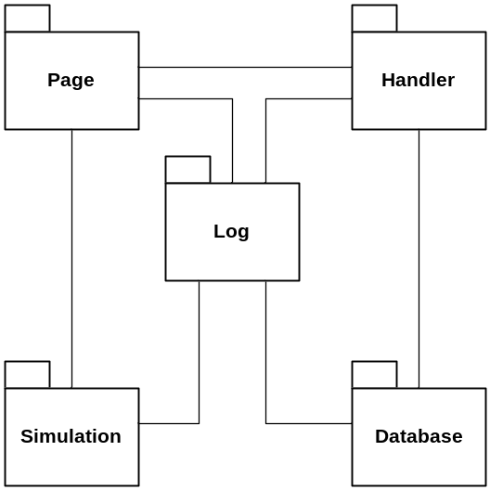

4.1.1 Page Subsystem
The Page subsystem will be one of the main components of the XGene 360 application. It will create the user interface, process user data, and manage the interaction between XGene 360 and the users of the application. The users will be of four types: Administrator, Professor, TA, and Student.

The subsystem will be primarily responsible for generating the appropriate user interface for each of the user types, based on the privilege level specified by the User object. The creation, deletion, and modification of users, courses, and problems, along with the association and disassociation of problems with users and courses, will be managed within this subsystem. Furthermore, the subsystem will take database records and biological data to generate various HTML snippets to display the data in tables or graphs. Common functions, scripts, user interfaces, and variables that will be shared among all types of users will also be managed by this subsystem.

4.1.2 Simulation Subsystem
The Simulation subsystem will be the core component of the XGene 360 application. It will be responsible for performing all biological simulation-related operations such as calculating the trait values of plants, crossing selected parents, and producing the next generation by recombining genes.

4.1.3 Database Subsystem
The Database subsystem will be the central access point to the database. Any operations that will require the retrieval or modification of the data in the database will be done through the Database subsystem. The subsystem will be primarily responsible for creating the connection to the DBMS; however, the subsystem itself will not contain any SQL statements. All SQL statements will be stored in the proxy class for each subsystem that will interact with the Database class.

4.1.4 Log Subsystem
The Log subsystem will be responsible for tracking errors and SQL transactions throughout the execution of the XGene 360 application. These errors will include SQL errors, user login errors, and other errors that will be considered when the system malfunctions and does not perform the expected behaviour. Examples of transactions include the creation of a TA or the modification of a problem. The Log subsystem will be called from all subsystems to report an error.

4.1.5 Handler Subsystem
The Handler subsystem will be responsible for the creation and maintenance of information necessary for the server to: identify users, handle page redirection, and generate the SQL statements.

4.2 User View
User View of XGene 360 (Component Diagram):

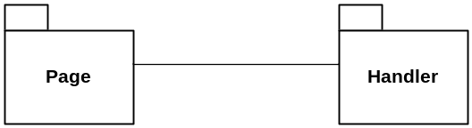

Access to XGene 360 will be authorized by the login process. A successful login will occur when the username and the password, provided by the user, is equivalent to one of the entries in the database. If no corresponding entry is found, the user will be denied access to the application, and an error message will be displayed to the user. If the authentication is successful, the corresponding User object will be created, which will be used to determine the privilege level of the user.

Each page of the application will perform a security check to ensure that the User object is allowed to execute the operation. If the user does not have the appropriate access level to carry out the operation, the operation will be cancelled, and a corresponding error message will be displayed. This security measure will be required to prevent users from accessing pages out of their user level privileges. The application will attempt to minimize unauthorized accesses to restricted information such as problem parameters or solutions.

５．Low Level Design

5.1 Modules

5.1.1 Page Module
The Page module will be made up of the following files.

Access Privilege:
A – Administrator can access this page
P – Professors can access this page
T – TAs can access this page
S – Students can access this page

Root Folder | Arguments | Access | Description
changepassword.php |  | A P T S | page where user can change his/her password
index.php |  | A P T S | page which redirects user to either the login page or initialization page
initialization.php |  | O | page where administrator is created
login.php |  | A P T S | page where user logins
logout.php |  | A P T S | page which is displayed when user logouts, redirects user to login page

Includes Folder | Arguments | Access | Description
config.inc |  | A P T S | page contains all configuration-related variables such as database server, username, and password
global.inc |  | A P T S | page where a list of global variables are defined
header.inc |  | A P T S | page which contains common HTML code at the beginning of all pages
footer.inc |  | A P T S | page which contains common HTML code at the end of all pages
navi.inc |  | A P T S | page which contains the HTML code for the navigation bar

Admin Folder | Arguments | Access | Description
managecourses.php |  | A P | page where a list of courses is displayed, along with options to create, delete, import, export courses
manageproblems.php |  | A P T | page where a list of problems is displayed, along with options to create, delete, assign problems if user is a professor or administrator
manageprofessors.php |  | A P | page where a list of professors is displayed, along with options to create, delete professors, and assign professors to courses
managestudents.php |  | A P T | page where a list of students is displayed, along with options to create, delete students, and assign students to problems or courses if user is a professor or administrator
managetas.php |  | A P | page where a list of TAs is displayed, along with options to create, delete TAs, and assign TAs to problems or courses
viewcourse.php | courseid | A P | page where a list of users and problems associated with that course is displayed, along with options to modify the course, and disassociate users or problems from that course
viewproblem.php | problemid | A P T | page where a list of users associated with that problems displayed, along with options to modify the problem, and disassociate users from that problem if user is a professor or administrator
viewprofessor.php | professorid | A P | page where the details of a professor is displayed, along with options to modify the details of the professor
viewstudent.php | studentid | A P T | page where the details of a student is displayed with a list of problems assigned to him/her, along with options to modify the details of the student if user is a professor or administrator
viewstudentsolution.php | problemid  studentid | A P T | page where a student solution is displayed, along with options to create a feedback
viewta.php | taid | A P | page where the details of a TA is displayed, along with options to modify the details of the TA

Student Folder | Arguments | Access | Description
submitproblem.php | problemid | S | page where students can enter the answers for the problem
viewgeneration.php | problemid  generationid | S | page where plants of a generation is displayed, along with histograms for each trait
viewproblem.php | problemid | S | page where a list of generations that the student has generated by working through the problem, is displayed
viewproblems.php |  | S | page where a list of problems that are assigned to the student is displayed
viewsolution.php | problemid | S | page where the solution of the problem is displayed, along with feedback from professor or TA

5.1.2 Simulation Module
The Gene class will model the genes of plants as a String. The Trait class will model the traits of plants with a trait name, the highest and lowest possible values for that particular trait, and the difference between the values. The Plant class will model a plant with two traits. Each trait will be able to be controlled by an arbitrary number of genes, in which the number lies between 2 and 50. The Simulator class will provide the methods for biological simulation.

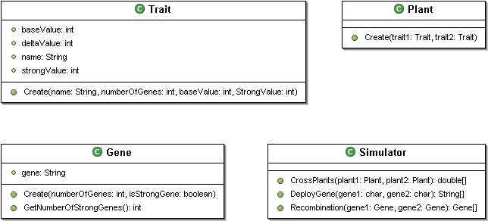

5.1.3 DatabaseManager Module
The DatabaseManager module will perform all database related activity. Upon creation, it will establish a connection with the database.

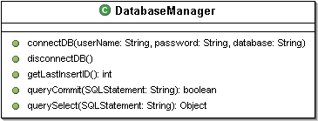

5.1.4 Logger Module
System errors and SQL transactions will be handled by the Log module. This module will be primarily responsible for recording system errors and successful transactions, meaning that it will not register invalid actions performed by users, or aborted transactions.

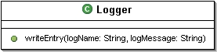

5.1.5 Handler
The UserHandler class will authenticate the user, and return a User object created by the User class upon success. The PageHandler class will redirect the user to his or her initial starting page based on the privilege level specified by the User object created after authentication. The CookieHandler class will provide the server with the ability to identify different users through cookies. This information will then be used to validate the users on each page to ensure that the user has privilege to access the information. The SQLHandler class will act as a proxy to the Database subsystem by generating SQL statements for the application. Since the different types of database queries have not been finalized, the methods for this class are incomplete.

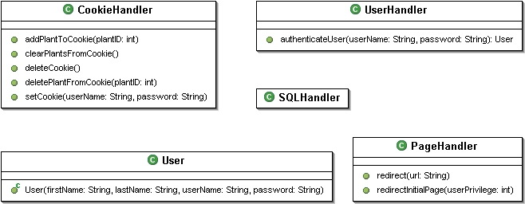

5.2 Sequence Diagrams
Please take note that there will be a lot of functions that will have similar sequence diagrams. In order to increase readability of the document, any word surrounded by “[” and “]” will be denoted as variables. The tables below the sequence diagram will show a listing of the types of functions the particular sequence diagram is representing. The sections are grouped by sequence diagram, rather than by user, for similar reasons.

5.2.1 Common Login Sequence Diagram

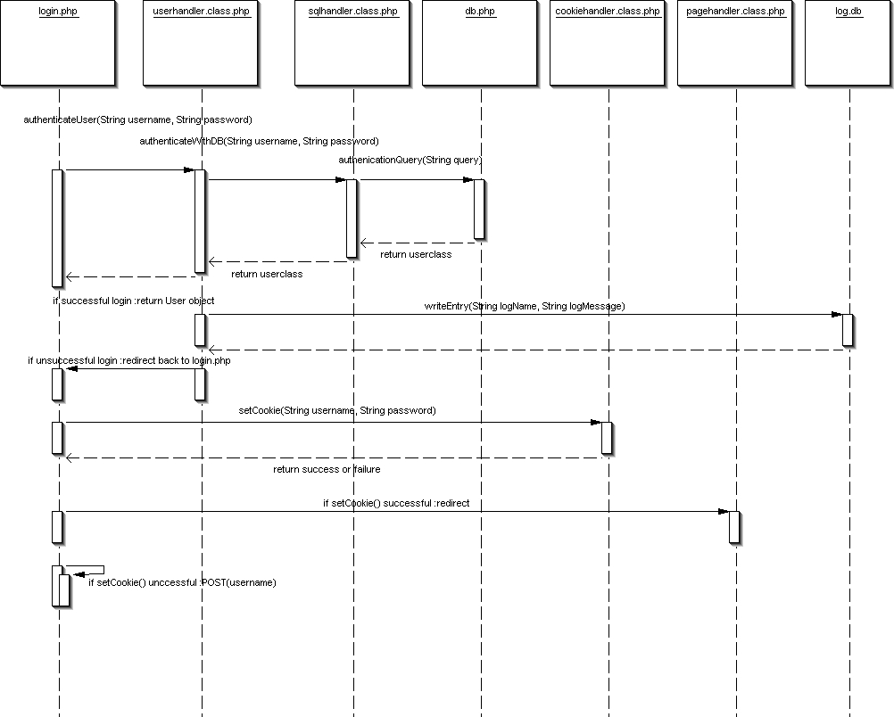

Common Sequence | Description
Login | Given a username and password as input, the system attempts to verify whether the user is in the database. If success, then the user is logged in. In the case of failure, the user is prompt to try again.

5.2.2 Common Logout Sequence Diagram

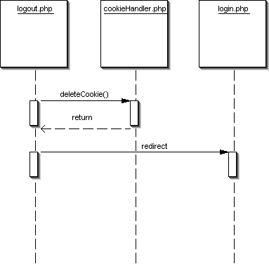

Common Sequence | Description
Logout | Given a prompt from the user to logout. The system will notify the cookie handler to delete the user’s cookie and then redirects the user to the login page.

5.2.3 Plant Cookie Sequence Diagram

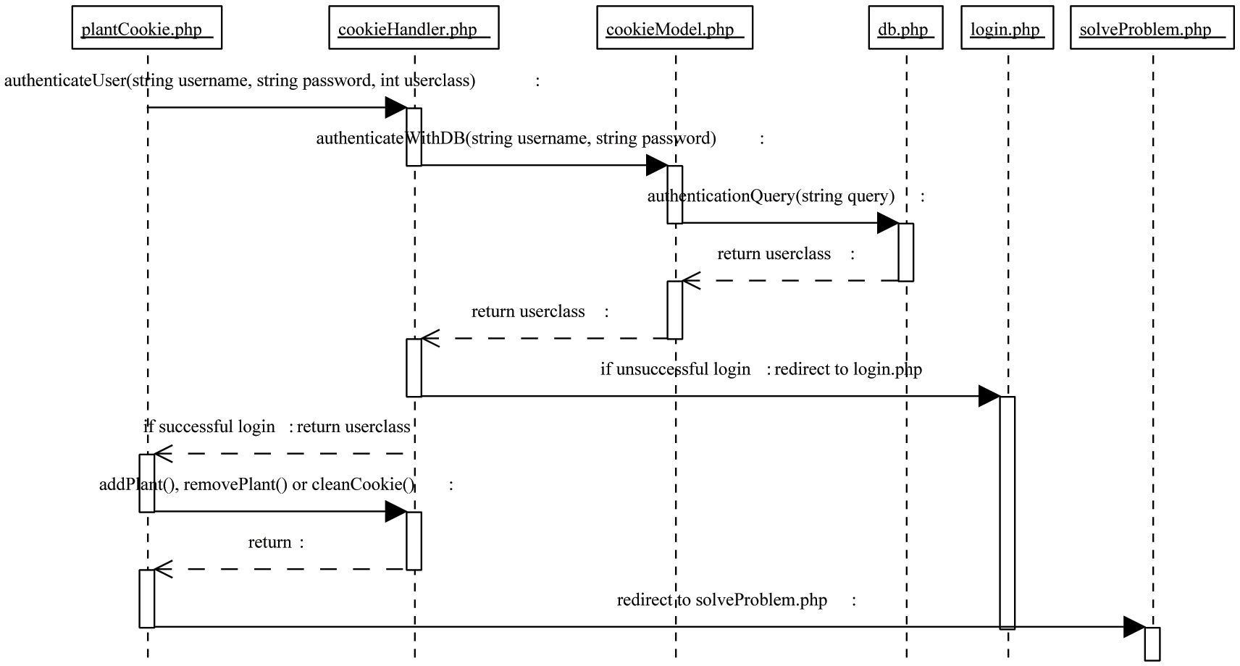

Sequence | Description
Plant Cookie | Upon request for action, the system verifies the authentication of the username and password before allowing the user (student) to create/remove/clear any plant information (indirectly).

5.2.4 Verify Cross Sequence Diagram

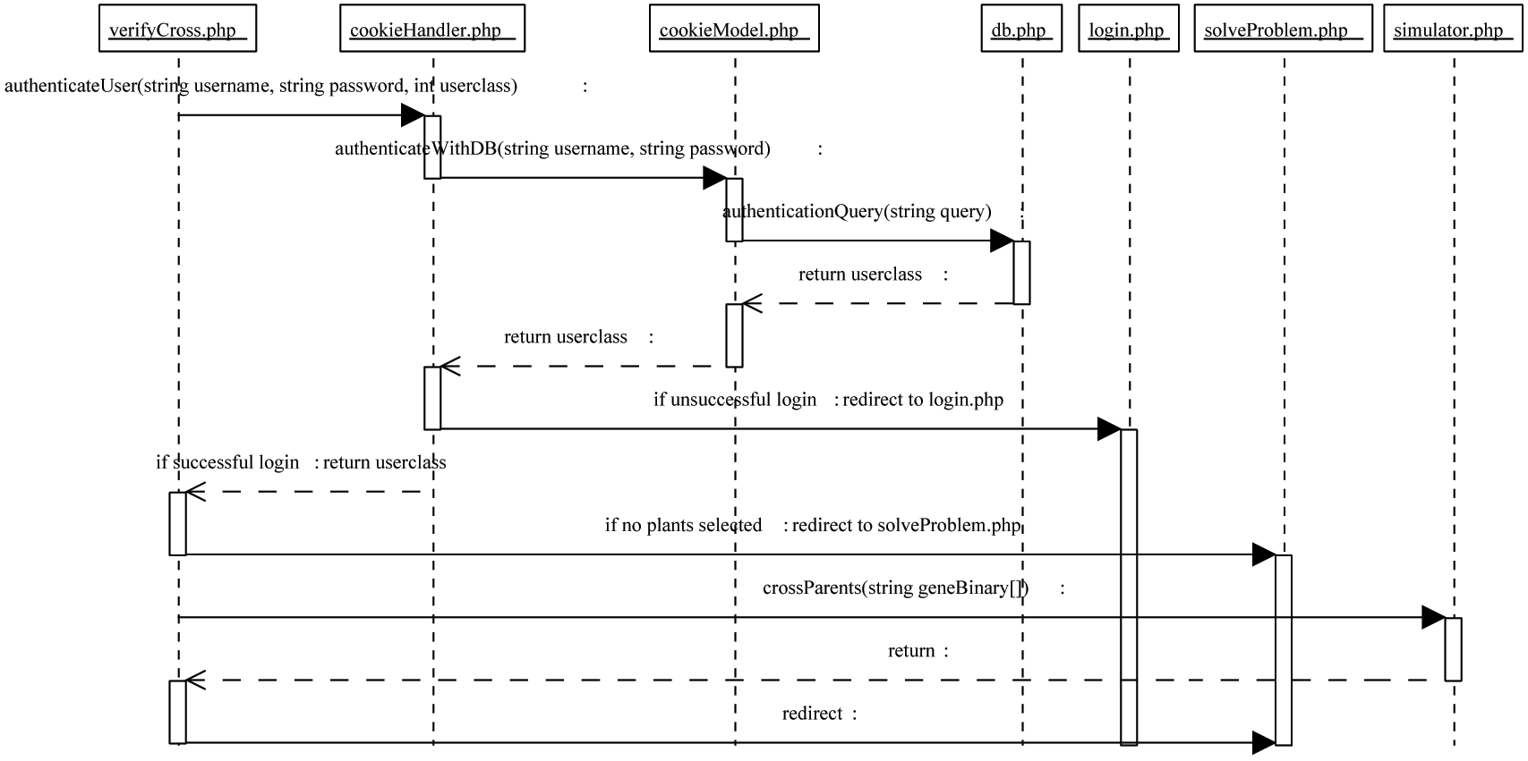

Sequence | Description
Verify Cross | Upon request for action, the system verifies the authentication of the username and password before allowing the student to make a cross between parents via the simulator. If there are no plants selected, then the system redirects the students to solve the problem.

5.2.5 Solve Problem Sequence Diagram

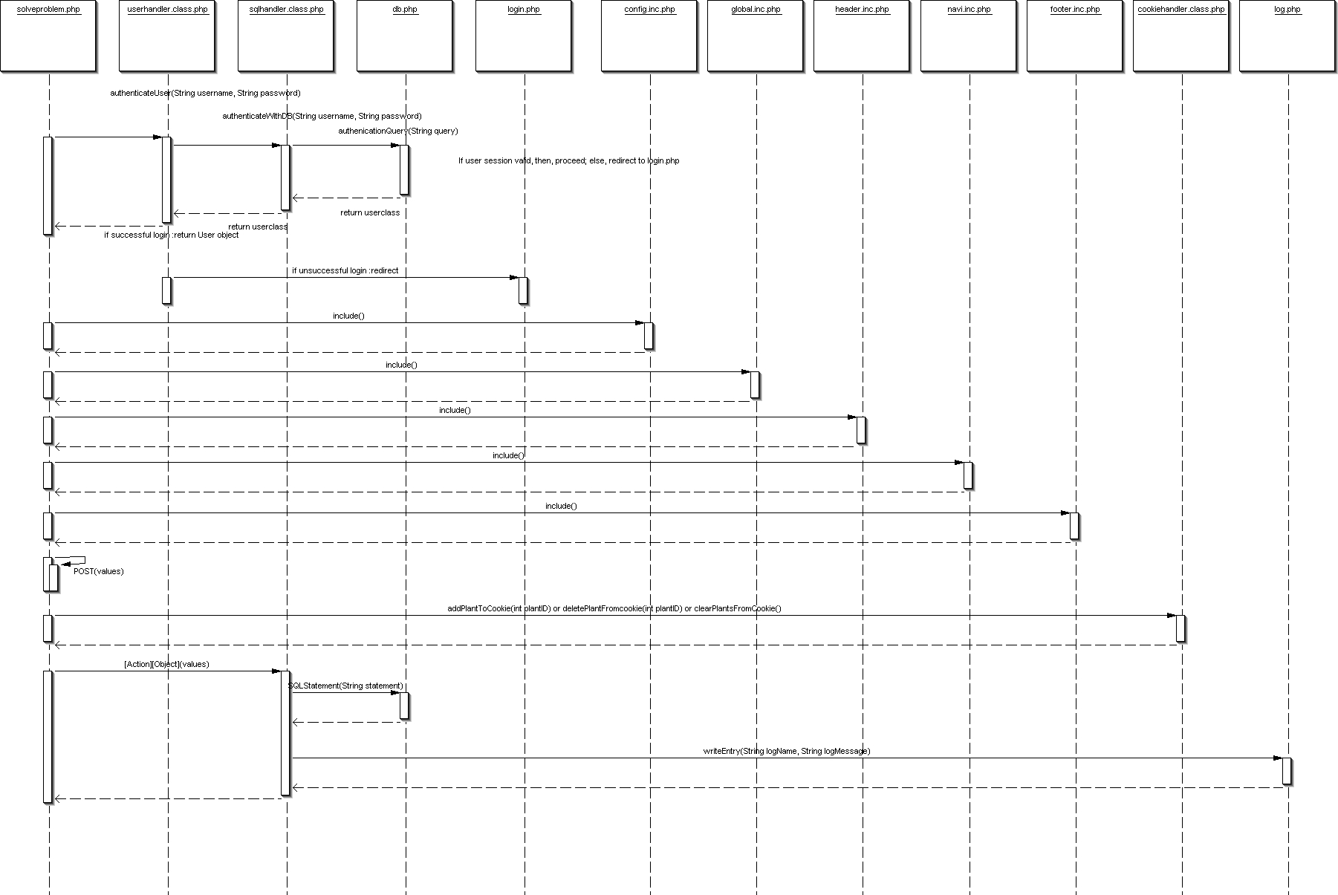

Sequence | Description
Solve Problem | Upon request for action, the system verifies the authentication of the username and password before allowing the student to be able to solve a problem.

5.2.6 [Action] [Object] Sequence Diagram

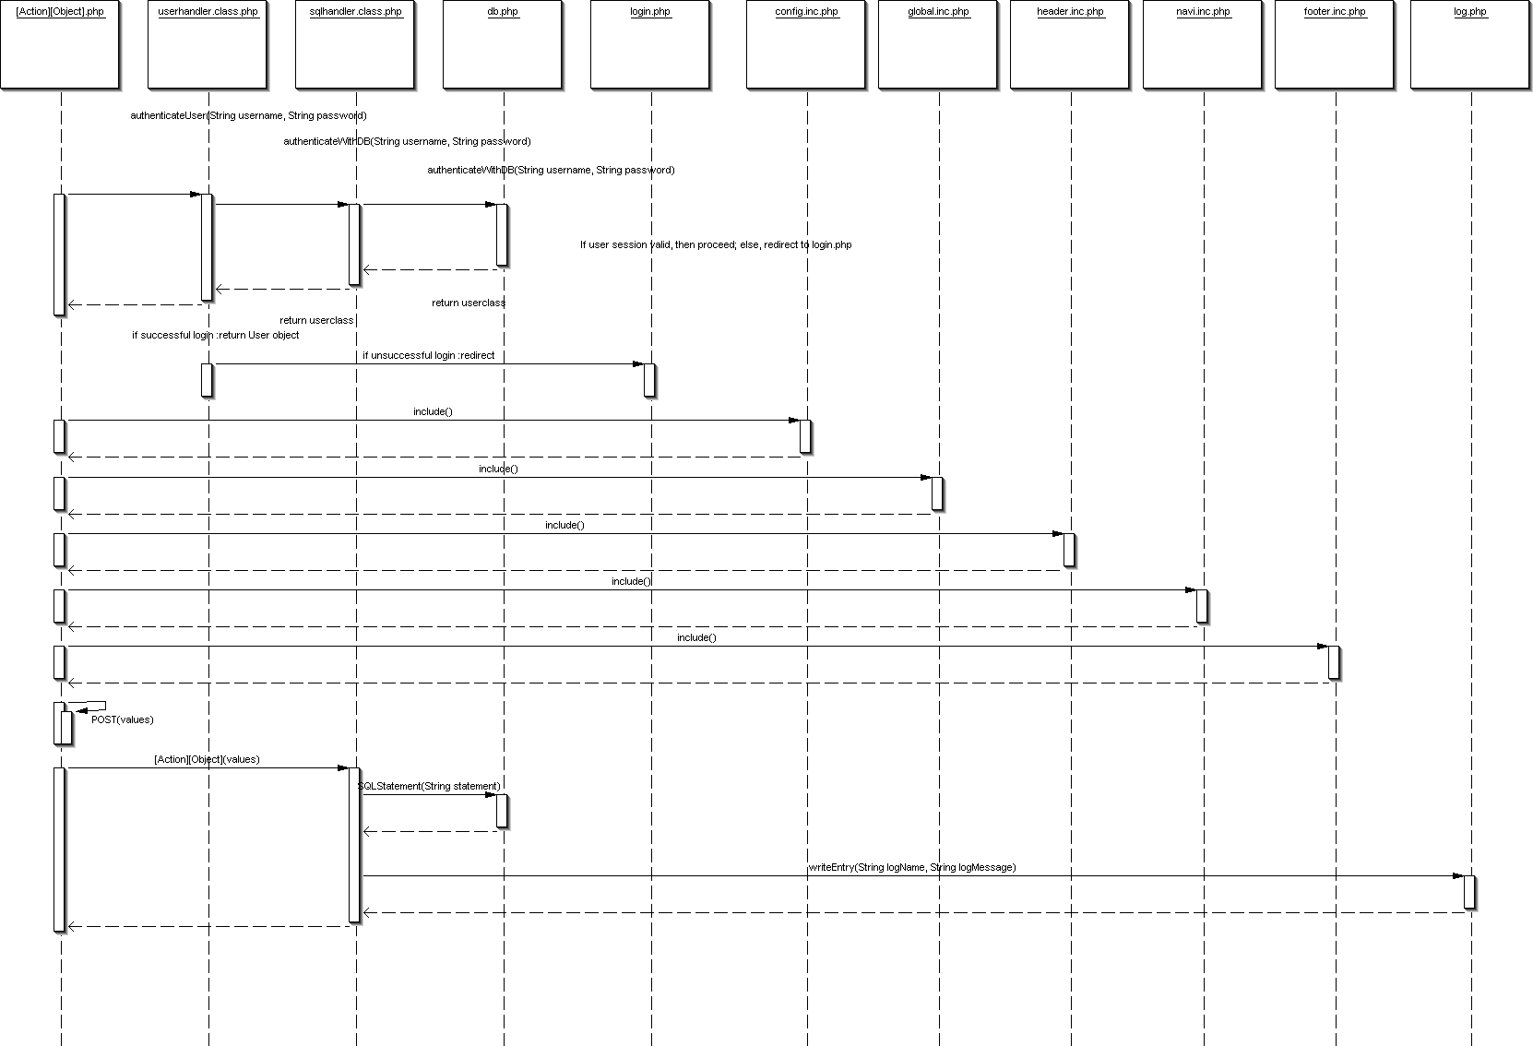

[Action] | [Object] | Description
Modify | Options | Upon selection, the system verifies the authentication of the username and password before allowing the user to view the modification pages.
Create/Delete/Modify | Administrator  Professor  TA  Student  Problem  AllProblems  Feedback  StudentSummary  Feedback  Courses  StudentsToCourse  TAsToCourse | Upon selection, the system verifies the authentication of the username and password before allowing the professor to see the page that allows him/her to create, delete or modify any one of the listed objects.
Verify | Feedback | Upon selection, the system verifies the authentication of the username and password before allowing the TA to see the page that allows him/her to verify feedback on a student’s solution.
Submit | Solution | Upon selection, the system verifies the authentication of the username and password before allowing the student see the page that will allow him/her to submit his/her solutions to be stored in the database.

6. User Interface Design

6.1 Application Control

XGene 360 will be a web-based application accessible through a web browser. The user will be navigating through a series of PHP pages hosted on a server in order to use the application. The screenshot below is a sample of the general visual interface of a typical page:

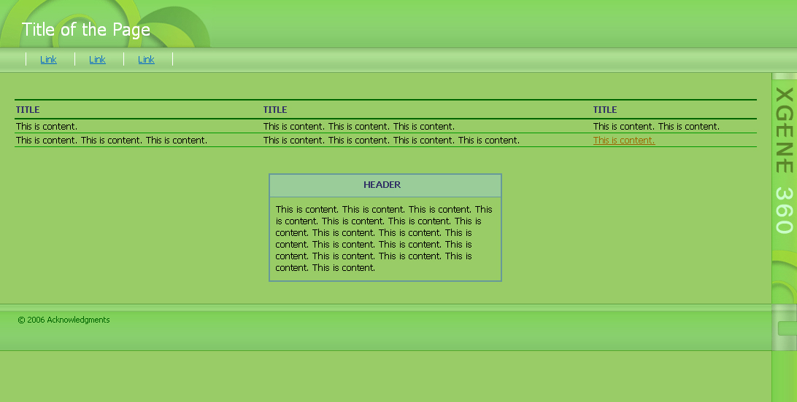

Figure 1: Screenshot of General Page

6.1.1 Common Look and Feel
The name of the application will be displayed on a vertical bar on the right side of the browser screen. The header portion will be situated on top and will display a plant graphic. Page titles will be displayed on the left corner of the header. Below the header will be the navigation bar, which will display links available to the user to select from. These links will vary from user-to-user. The content of the page will be displayed underneath the navigation bar and will vary from page-to-page. In terms of content, there will be the use of common table types, such as a table for listing objects or a table for displaying instructions. Underneath the page content will be the footer bar. The footer bar will only contain copyright information.

6.1.2 Common Behaviour
Since the application will be accessible through a web browser, user interaction will be similar to browsing any other web page on the Internet. The user will be able to use a mouse to select links in order to view other pages and select checkboxes and dropdown menus. With a keyboard, the user will be able to type input in form fields.

Upon initial access of the application, users will be brought to the login page. After entering the correct username and password combination, a list of problems associated with the user will be displayed. The user will then be given the freedom to browse the application.

6.2 Screens
The application will consist of numerous pages. For the sake of conciseness and clarity, the screens will be categorized by page function, such as viewing course details or login. There will not be a screen for every single page. Instead, there will be selected screens for each page function category.

6.2.1 Screen Venn Diagram
A Venn diagram is generally used to show relationships between sets, which are represented by circles that intersect with each other. This diagram will be chosen over a transition diagram to display flow control because there will be multiple ways to access a certain page. A transition diagram for this application will be very confusing as a result. A Venn diagram will provide a cleaner view.

Each circle of the Venn diagram will represent a user. Inside each user circle will be the pages that each user will be able to access. Overlaps of circles will display the pages that several users will have access to. The numbers in the overlapping sections correspond to the last number of the sections below the diagram (i.e. the number “1” corresponds to 6.2.1.1). A detailed explanation of each page will be shown in subsequent sections 6.2.2-6.2.9.

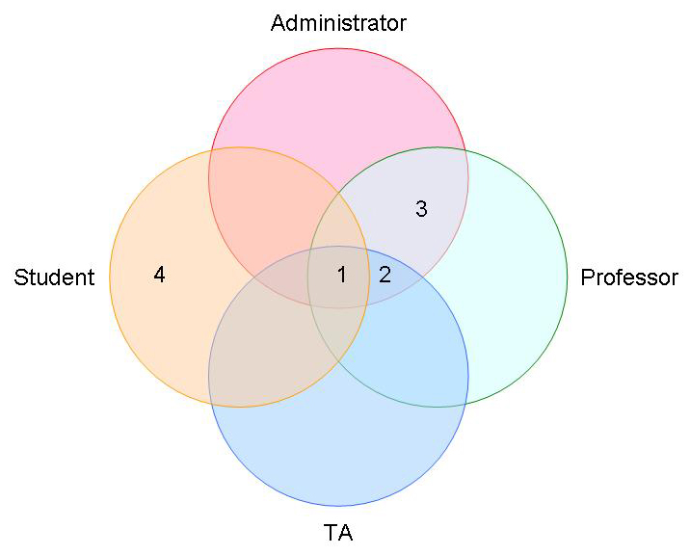
Figure 2: Screen Venn Diagram

6.2.1.1 Common Pages for All Users
Login
Logout
Change Password
List of Problems
Problem Details
Problem Solution Details

6.2.1.2 Pages for Administrator, Professor, TA
List of Students
Student Details

6.2.1.3 Pages for Administrator, Professor
List of Courses
List of Problems
List of Professors
List of TAs
Course Details
Professor Details
TA Details

6.2.1.4. Pages for Student
List of Generations
Submit Problem

6.2.2 Login
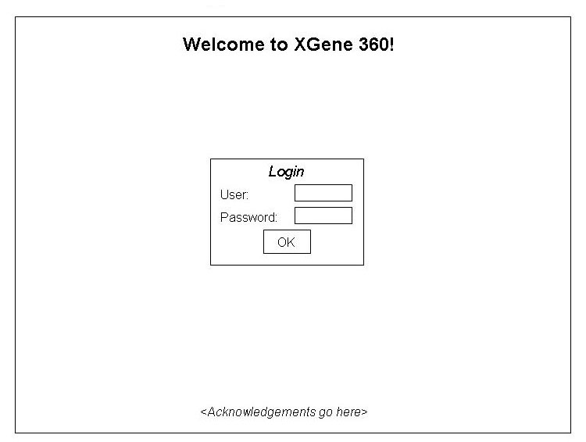
Figure 3: Login

Name | Login
Description | The first page a user will see. It will allow a user to login to the application.
Users | Administrator, Professor, TA, Student
Inputs | - Username  - Password
Outputs | The application will accept login information and bring the user to a list of problems that the user is associated with.
Possible Errors | An invalid login will result in a message indicating that the information is incorrect.

6.2.3 Logout
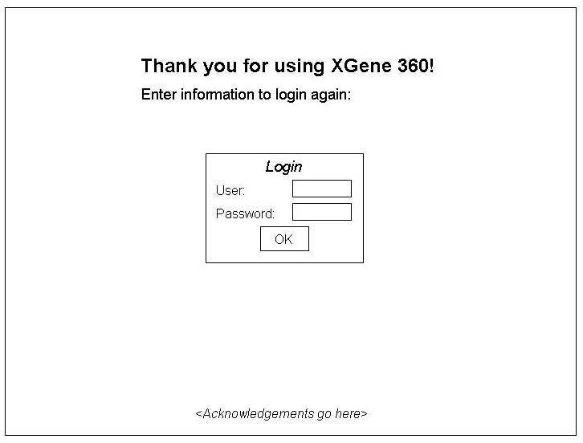
Figure 4: Logout

Name | Logout
Description | To logout, a user will press a button labelled “Logout” and will be directed to the logout page.
Users | Administrator, Professor, TA, Student
Inputs | None
Outputs | The application will log out of the user’s account and show the logout page, which will give the user an option to login again.
Possible Errors | None

6.2.4 Change Password
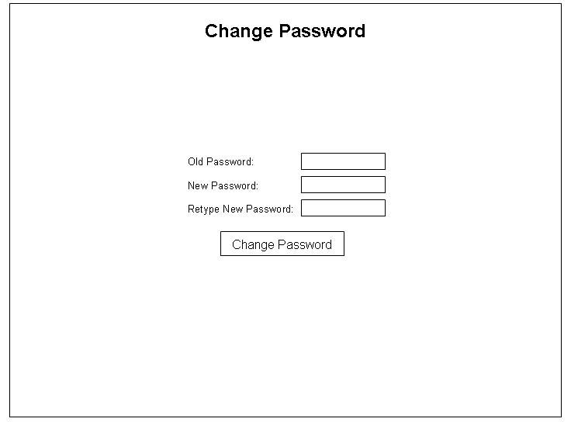
Figure 5: Change Password

Name | Change Password
Description | User will be able to change his/her password.
Users | Administrator, Professor, TA, Student
Inputs | Old password, New password (twice)
Outputs | After clicking the “Change Password” button, the user’s new password will become the current password.
Possible Errors | Errors will result in the clearing out of the fields in order for the user to fill out the information again. Errors will be caused by the following:  - The old password is invalid  - The “New Password” and “Retype New Password” fields do not have the same input

6.2.5 Lists
There will be several types of lists for objects such as students and courses. The tables that will display the objects will all have a similar interface. Differences in the content of the tables will depend on two things – the type of the object and the type of user viewing the list.

For each object, there will be table fields that will be relative to the object. For example, a list of problems will have table fields such as “Start Date” and “Course” while a list of generations will have table fields such as “Histograms” and “Parents”.

Students and TAs will be able to click on object’s name in a list to view a page of the details for the particular object.

The administrator and professors will also be able to click on an object to view the object’s details. In addition, the administrator and professors will be able to create and manage objects. The option to create an object will be shown as a link labelled as “Create [Object]”, where [Object] will be replaced by the actual object type (i.e. Course/TA). Upon clicking the link, a form will appear within the same page with form inputs for the user to fill out. To modify/delete a particular object, the user will click the object to view the details. On the details page, the user will be able to modify certain fields and press the “Modify” button to submit the changes or simply delete the object by pressing the “Delete” button. The user will also be able to do modification in batches by selecting several objects via checkboxes.

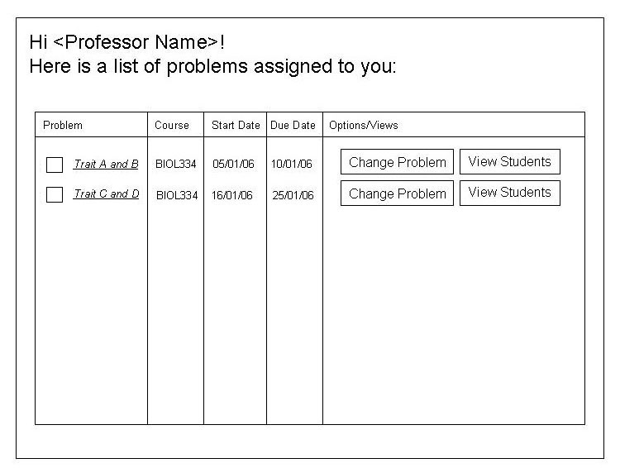
Figure 6: List of Problems for Professor

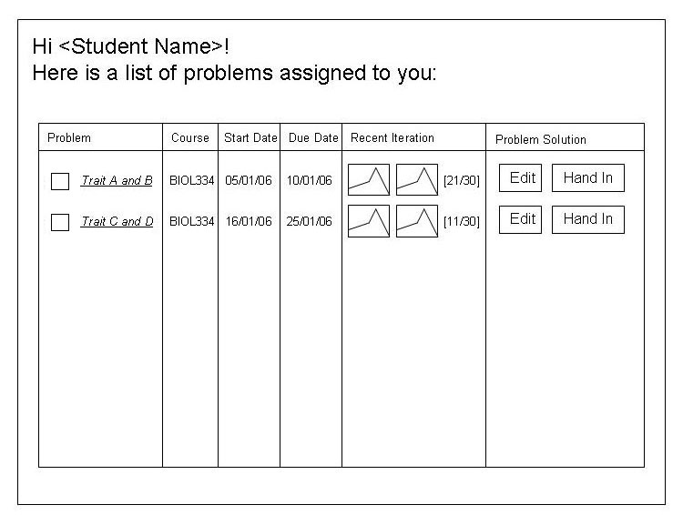
Figure 7: List of Problems for Student

Name | List of Problems
Description | A user will be able to see a list of problems associated with the user. Details for each problem will be viewable by clicking on a problem name. User-specific options will be available as well.
Users | Administrator, Professor, TA, Student
Inputs | None
Possible Outputs | These will be the possible outputs, depending on the type of user:  - Changing problem parameters  - Viewing students and/or TAs assigned to problem  - Editing problem solution  - Handing in problem solution
Possible Errors | None

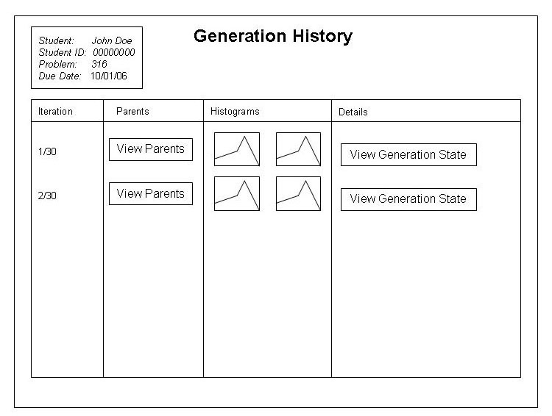
Figure 8: View Generation History

Name | List of Generations
Description | The user will be able to view a generation history for the current problem.
Users | Student
Inputs | None
Outputs | These will be the possible outputs, depending on the user’s selection:  - View the parents for the generation.  - View the problem state for that generation.
Possible Errors | None

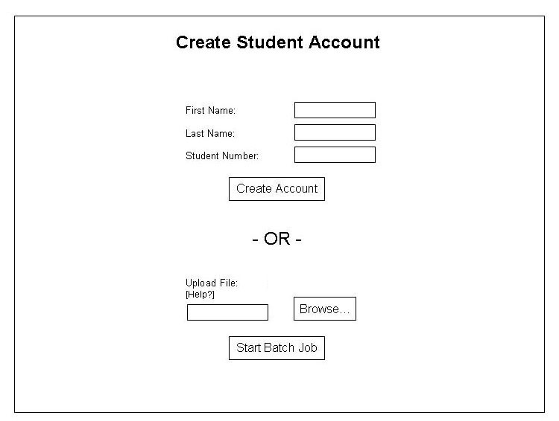
Figure 9: Create Student

Name | Create Student
Description | Will create a new student. This section will pop up within the list of students page when the user clicks a “Create Student” link.
Users | Administrator, Professor
Inputs | - First name  - Last name  - Password  - Assigned courses (optional)  The user will also be able to upload a text file with a list of student information.
Outputs | After verifying the inputs, the application will output a username and password. If the user provided an excel sheet, then a list of usernames and passwords will be provided.
Possible Errors | Invalid information will result in a message indicating that the information is incorrect.

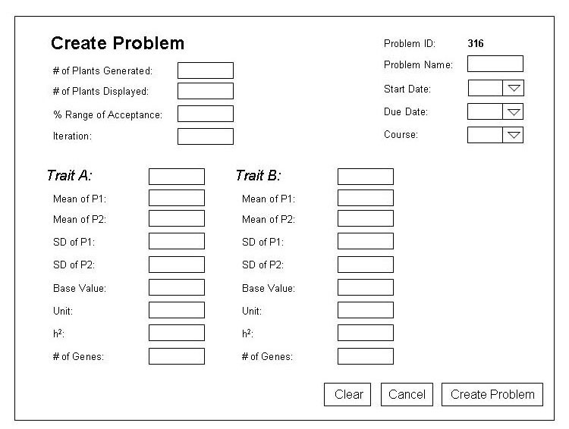
Figure 10: Create Problem

Name | Create Problem
Description | Will create a new problem. This section will pop up within the list of problems page when the user clicks a “Create Problem” link.
Users | Administrator, Professor
Inputs | Indicated by the above figure.
Outputs | After verifying the input, the application will output a message indicating success.
Possible Errors | Invalid field inputs will result in an error message.

6.2.6 Object Details
All objects in the application will have a page that outlines the object’s details. The content of each page will depend on the type of object.

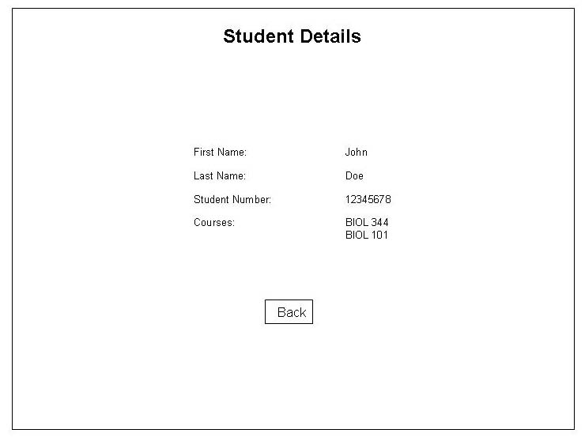
Figure 11: Student Details

Name | Student Details
Description | View the details of a particular student.
Users | Administrator, Professor, TA
Inputs | If the user is the administrator or a professor, these will be the possible inputs:  - First name  - Last name  - Password  - Assigned courses (optional)
Outputs | The application will lead the user back to the list of students. If the user is the administrator or professor, the application will verify the inputs as well.
Possible Errors | Invalid inputs will result in a message indicating that the information is incorrect.

6.2.7 Problem Details
There is a separate section for problem details because the interface is quite different from other object details.
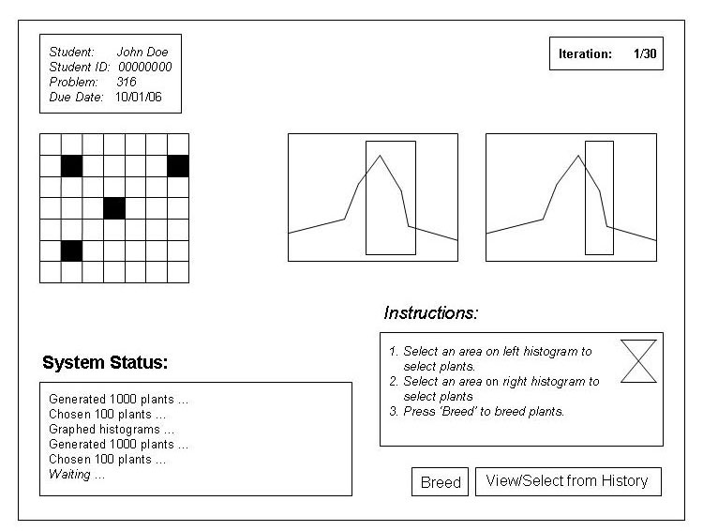
Figure 12: Problem Details for Student

Name | Problem Details
Description | The user will be able to view the details of a problem. If the user is a student and the problem is not finished, the user will be able to select plants for breeding.
Users | Administrator, Professor, TA, Student
Inputs | If the user is a student, the possible inputs will be:  - Seeds from areas highlighted from the grid. The highlights areas will come from the selected areas of the histograms.  - As an option, seeds from a previous generation
Outputs | If the user is a student and the problem is not finished, breeding will occur, and the problem details for the next generation will appear, allowing the student to continue.
Possible Errors | None

6.2.8 Problem Solution Details
There is a separate section for problem solution details because the interface is quite different from other object details.
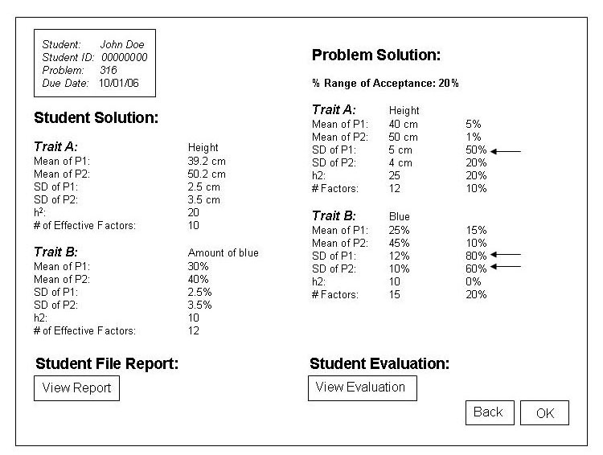
Figure 13: Problem Solution Details for Student with Feedback Returned

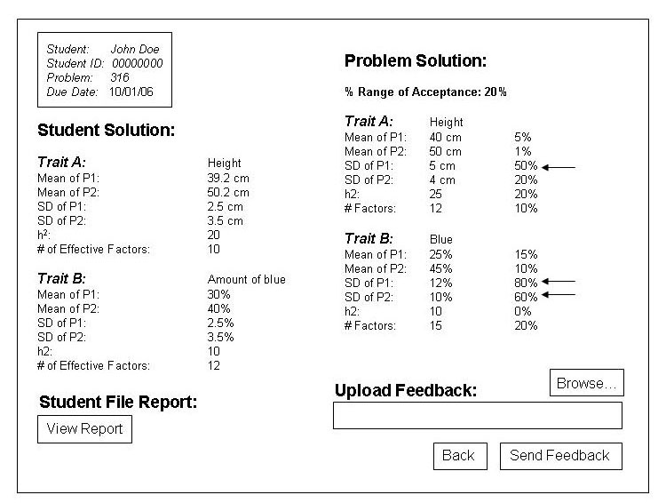
Figure 14: Problem Solution Details for Professor with Feedback Field

Name | Problem Solution Details
Description | The user will be able to view student results for a problem as well as any feedback from the professor or TA.  If the user is the administrator, a professor or a TA, the user will also be able to upload an evaluation/feedback file.
Users | Administrator, Professor, TA, Student
Inputs | If the user is the administrator, a professor or a TA, an evaluation/feedback file upload will be optional.
Outputs | If the user is the administrator, a professor or a TA, a prompt will pop up verifying the success of sending the evaluation.
Possible Errors | Evaluation file is invalid, so the application will output a message indicating that a valid file should be used.

6.2.9 Submit Problem
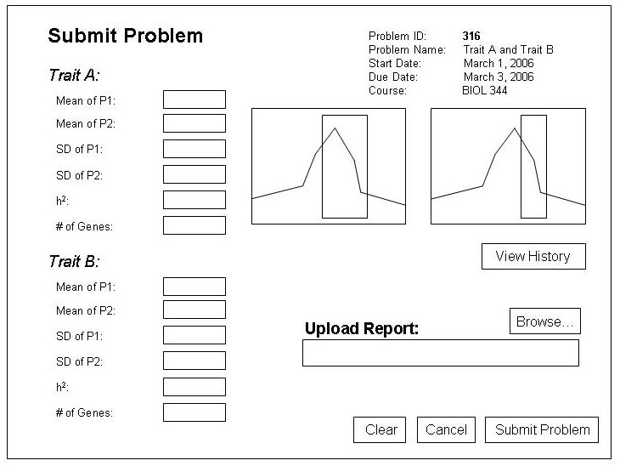
Figure 15: Submit Problem

Name | Submit Problem
Description | Will allow the user to submit solutions to a problem.
Users | Student
Inputs | Indicated by the above figure.
Outputs | After verifying the input, the application will output a message indicating success.
Possible Errors | Invalid field inputs will result in an error message. Also, if the report file is invalid, the application will output a message indicating that a valid file should be used.

